WARP Terminal:
Creating directories-file-1:
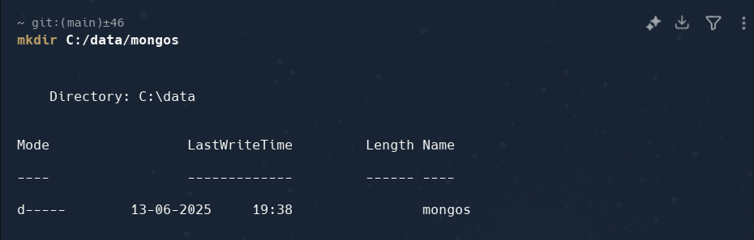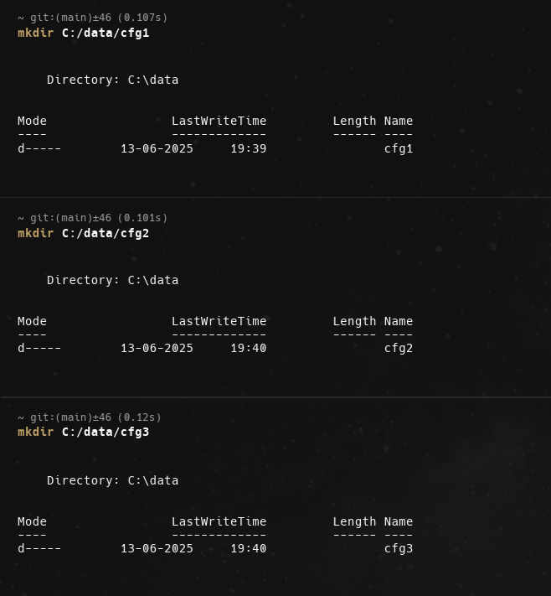
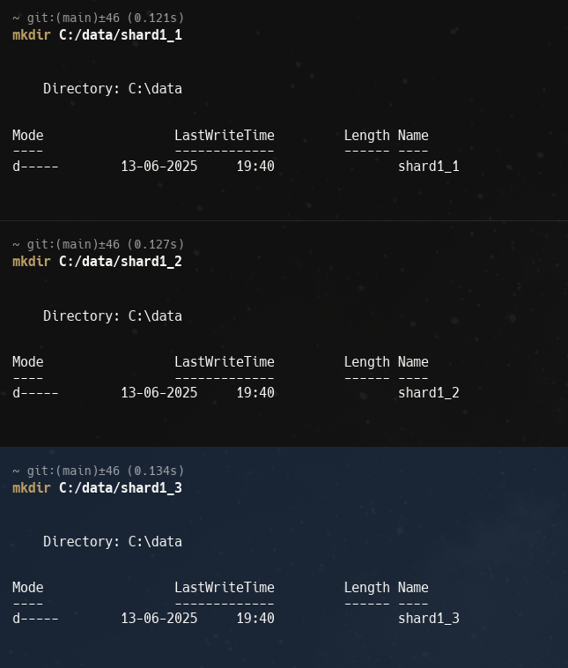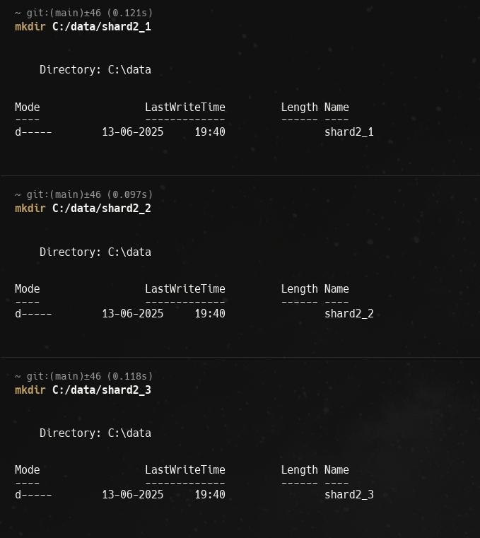
# Config Server 1
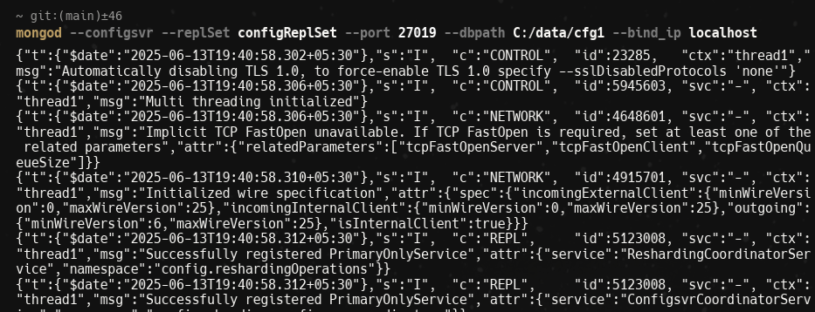
# Config Server 2
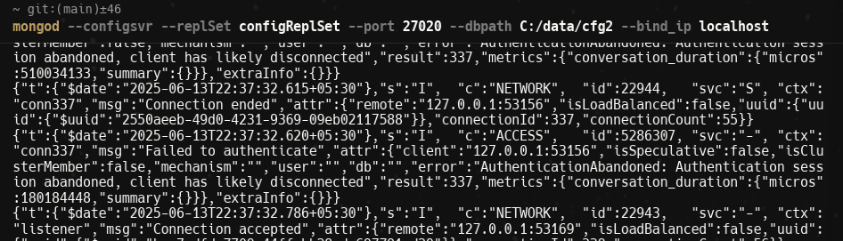
# Config Server 3
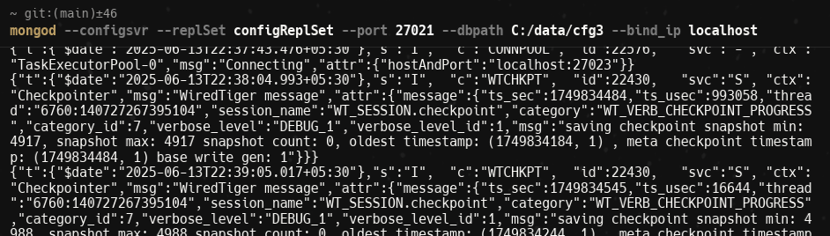
# Config Replica set:
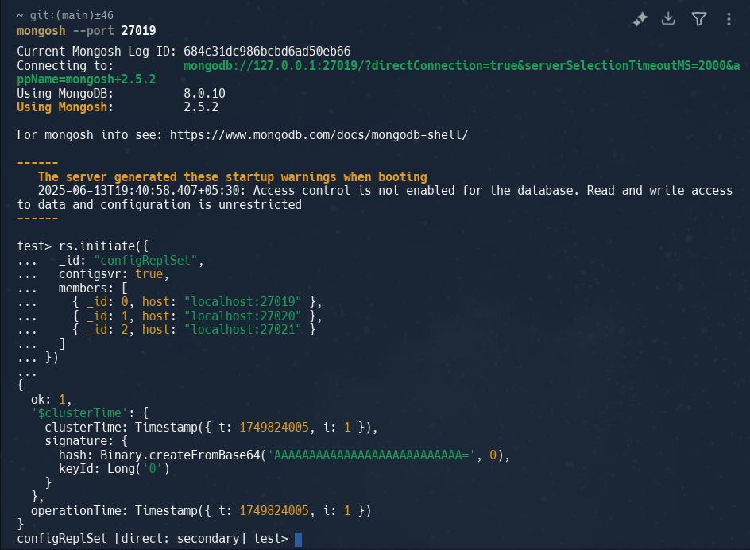
Shard Replica Sets:
# Shard1 Node1
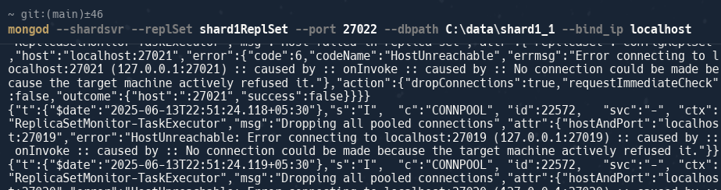
# Shard1 Node2
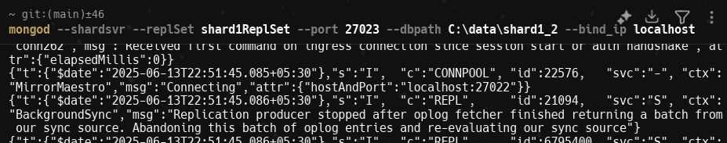
# Shard1 Node3
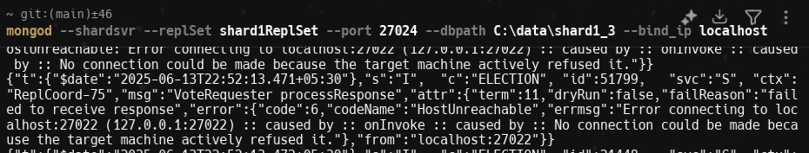
Initialize Shard 1:
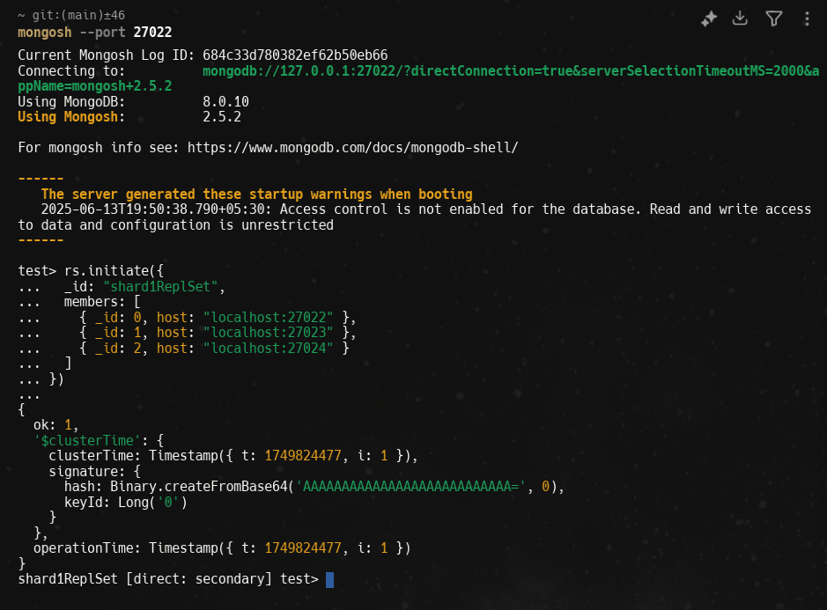
# Shard2 Node1
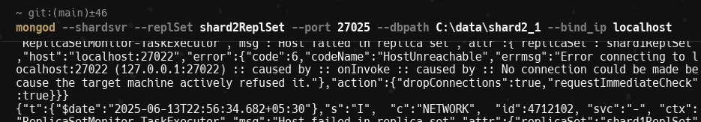
# Shard2 Node2
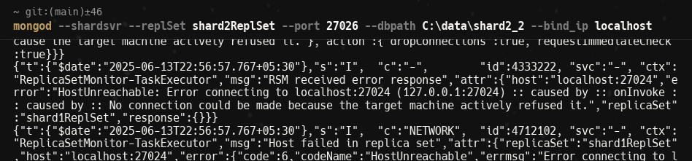
# Shard2 Node3
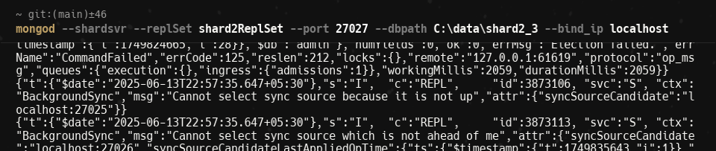
Initialize Shard 2:
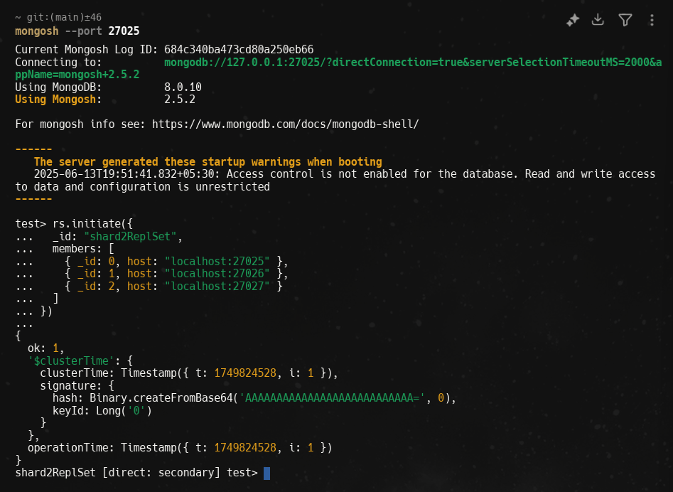
Mongos Query Router:
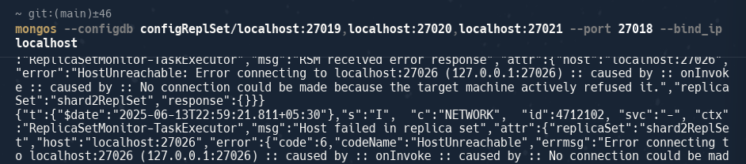
Configure Sharding:
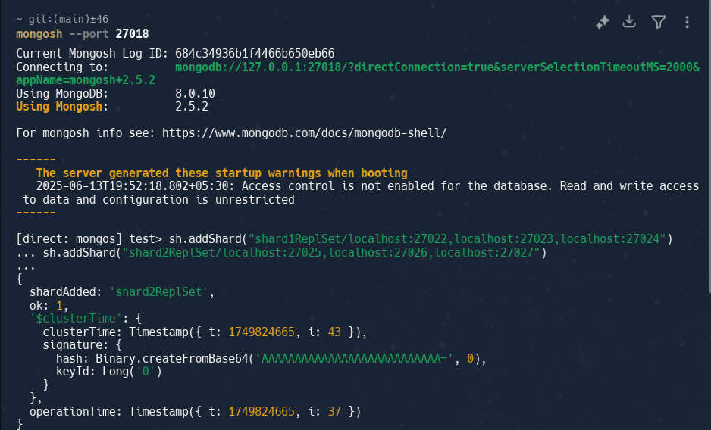

sh.status():
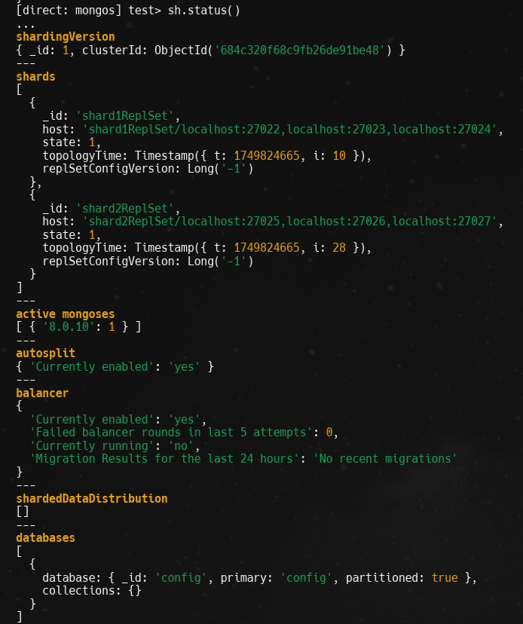

Enable Sharding for a Database and Collection:
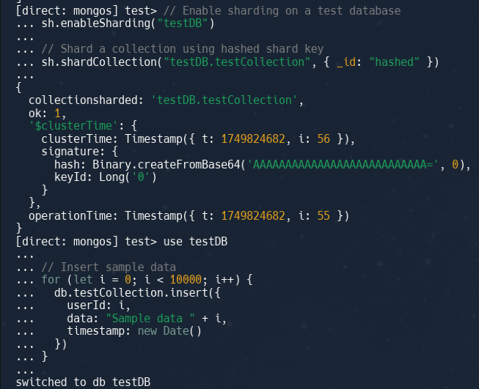
Check distribution: